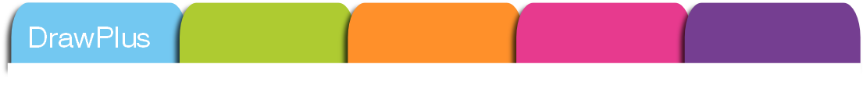
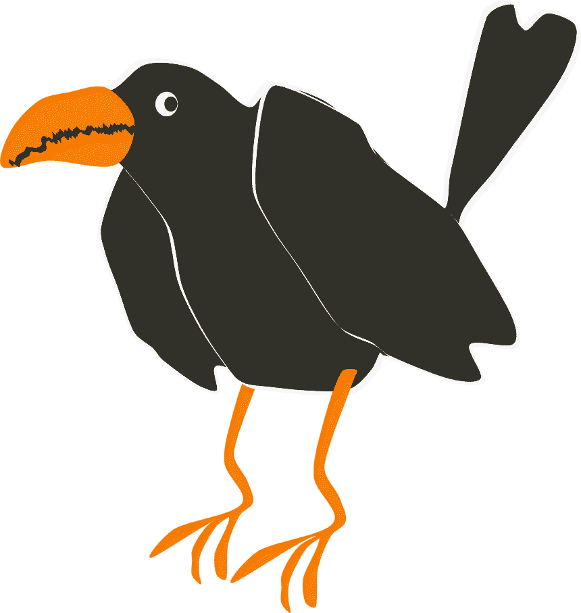
How to …
start an animation in DrawPlus X4 stop-frame mode

With DrawPlus, it's easy to create animated GIFs and AVI movies with multiple images, stored as frames that a web browser can play back in series. Animation Mode provides a special toolbar and a tabbed interface so you can create individual frames, preview the animation, and export it as a standalone GIF or as an AVI file.

 | Take a few minutes to identify the range of Toolbars and Studio tabs. You can toggle them on and off via the commands on the View menu, where you can also access Layout tools that you may need later like Rulers, Guides, a Snapping Grid and scale features. Although these are essential for any layout tasks on a webpage or poster, for example, the most useful tool for consistent layout from frame to frame in a stopframe animation is Onion Skinning, which allows you to see a selected number of previous frames underneath the active one in order to place objects accurately.
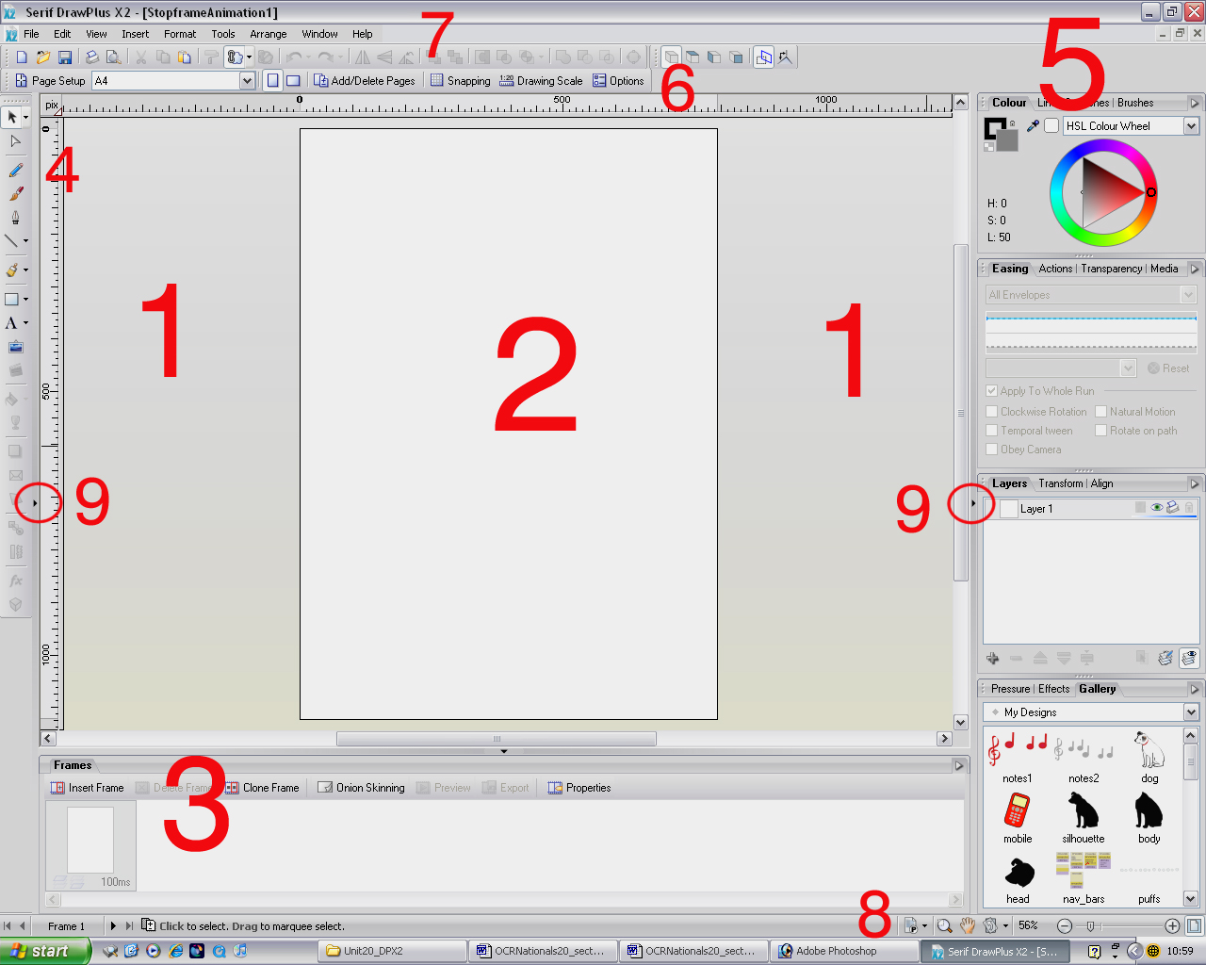

KEY:
1 = Pasteboard (space to park elements while you compose the frame)
2 = Animation frame (choose portrait or landscape formats; in drawing mode this is called the Page)
3 = Frames tab (allows you to assemble and manage your frames. This is replaced by the Pages tab in drawing mode and by the Storyboard tab in keyframe animation mode)
4 = Drawing toolbar (available in all modes – new vector edit tools are the eraser, freeform paint brush and knife to create slices)
5 = Studio tabs (some are exclusive to keyframe animation e.g. Easing, Media and Action tabs)
6 = Context toolbar (available in all modes – it changes to reflect options for the selected tool)
7 = Standard toolbars (available in all modes)
8 = Zoom toolbar (get in close or work at actual size)
9 = Toggle hidden tabs (click the small black arrow to reveal or conceal them: the second screenshot shows the How to tab made visible).

 | Take a closer look at the Animation toolbar on the Storyboard tab. DrawPlus automatically starts a new animation with Frame 1. The buttons are clearly labelled.
Starting a new animation

 | 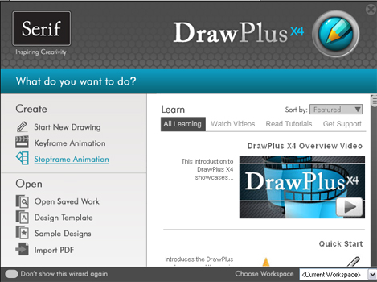  On the Startup Wizard, choose Create > Stopframe Animation.  Alternatively, you can select New>New Stopframe Animation from the File menu. A new document window opens in Stopframe Animation mode.
 | 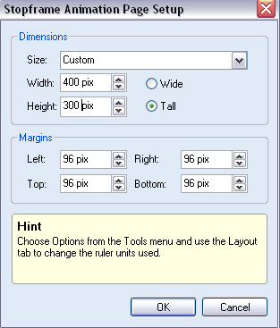  Select a set page size and orientation.  You can also change to a custom size on the drop down Context > Page Setup menu, or click on to key in your preferred dimensions.  The example ‘Crowfield Vincent’ stopframe animation is 400 pixels by 300.
 | DrawPlus automatically creates the first blank frame for you.  On the Frames tab create some new blank frames by clicking on the Insert Frame icon.  However, it is advisable to compose your starting frame first and then use the Clone Frame button to reproduce it, making adjustments to its placement, size, colour, features as needed. You will find other time-saving hints in the ‘How to clone, tween and save time’ tutorial.

